Project Development Phase

|  |  |
| --- | --- |
| **Team ID** | **PNT2022TMID41669** |
| **Project Name** | **IoT Based Safety Gadget for Child Safety Monitoring and Notification** |

SPRINT I:- Database connection in Nodered:

Link: [https://node-red-cdaue-2022-11-17.eu-de.mybluemix.net/red/#flow/40f9999a0fb0cc65](https://node-red-cdaue-2022-11-17.eu-de.mybluemix.net/red/%23flow/40f9999a0fb0cc65)

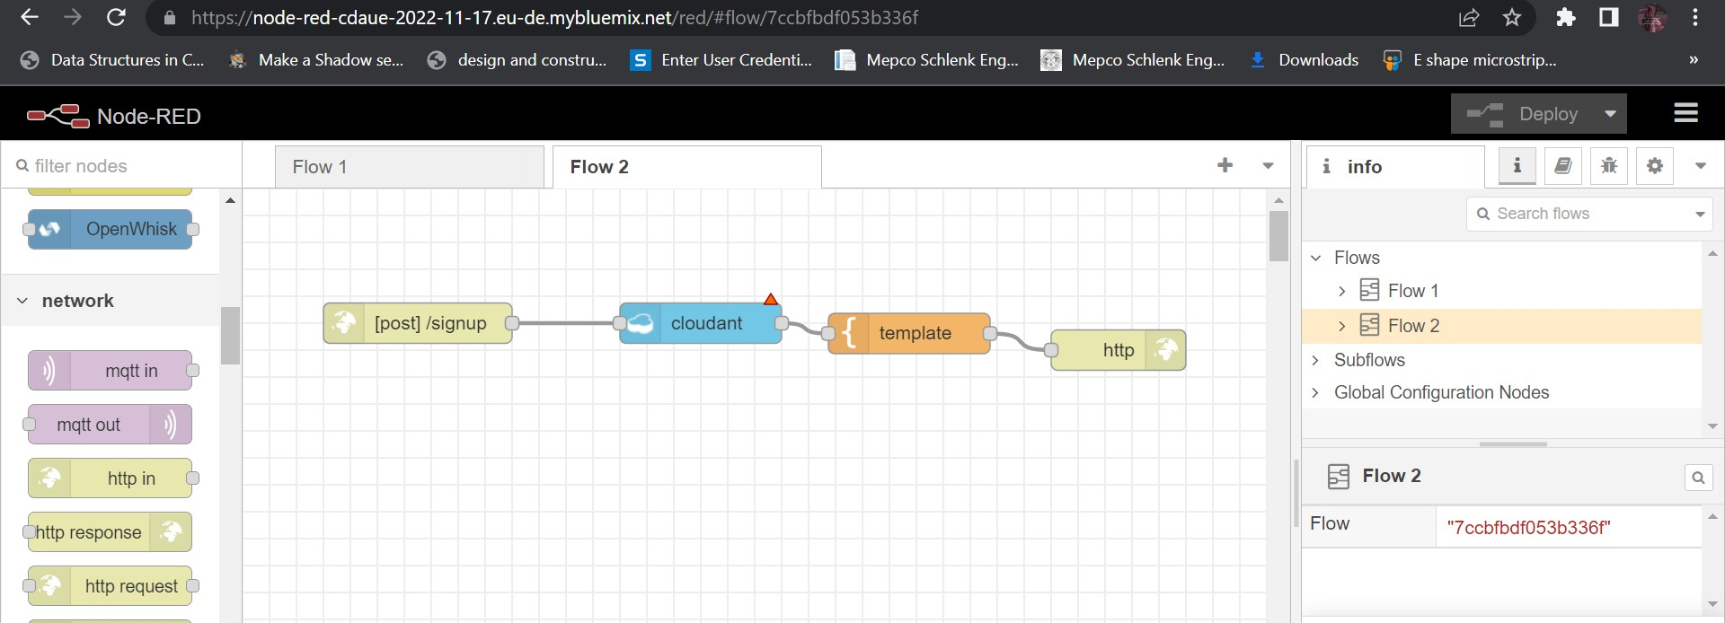

CLOUDANT KEYS:

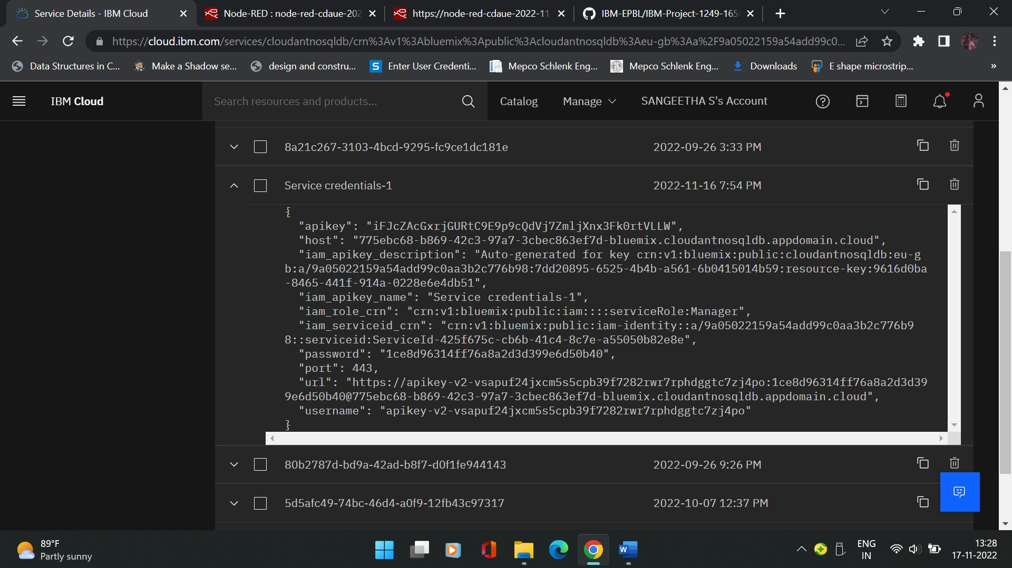

CLOUDANT DATABASE:

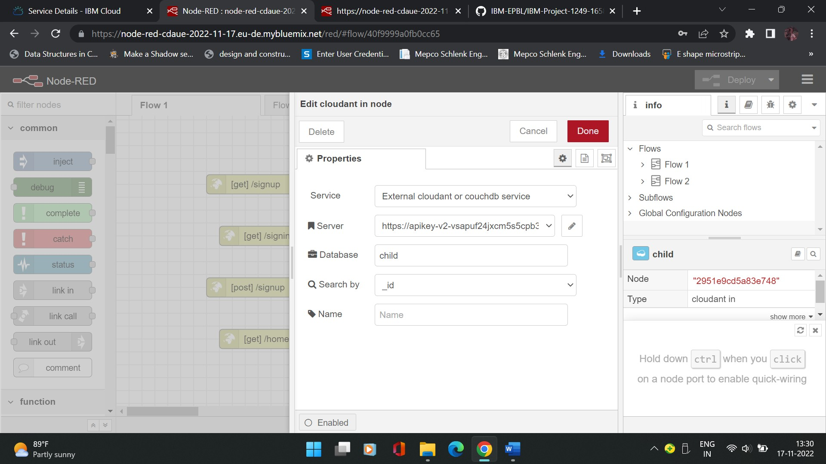

<https://node-red-cdaue-2022-11-17.eu-de.mybluemix.net/signup>

